**SaV64 User Guide**

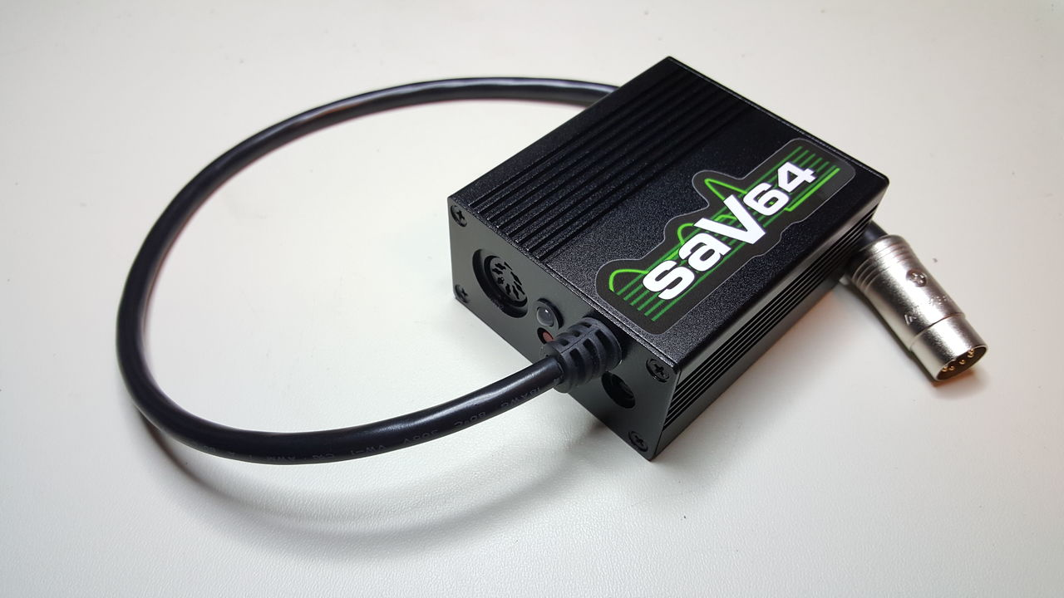

The SaV64 is an over-voltage protection device for Commodore 8-Bit computers that require both 5VDC and 9VAC power sources. It monitors the 5VDC voltage level and automatically disconnects both the AC and DC from the computer when it rises above the trip voltage.

**Features**

* Protect your Commodore 64(C/G/GS/Aldi), Commodore VIC-20 CR, or Plus/4 (with an adapter) from overvoltage on the 5VDC line.
* 5VDC and 9VAC Barrel connectors to allow easy use of alternative power sources. The 5VDC barrel input is also protected from overvoltage.
* Use an external 5VDC power source in conjunction with the Commodore power supply for 9VAC even when its 5VDC has failed.
* Designed to handle 3 Amps in order to protect and power your system.
* High quality relay that disconnects both DC and AC lines in the case of an overvoltage condition.
* Dual color LED indicating the 5VDC status: Normal (Green) or Tripped (Red).
* Can be reset with the recessed reset button or by unplugging the power source.
* Four possible trip point settings to customize the protection to your system.

**Using the SaV64**

The SaV64 will give the best protection using the following steps.

1. Attach a C64 power supply OR two power adapters (5VDC and 9VAC) to the SaV64. Do not connect a 5VDC power adapter to the SaV64 while a C64 power supply is connected without disconnecting the 5VDC from the C64 power supply first (See Below). Never connect a 9VAC power adapter to the SaV64 while a C64 power supply is connected.
2. With your computer turned off, plug the SaV64 into the computer.
3. Apply power to the SaV64.
4. Check the SaV64 status light. If it is green then turn on the computer. If it is red then begin troubleshooting.

**Troubleshooting**

|  |  |
| --- | --- |
| **Symptom** | **Solution** |
| SaV64 LED is not lit | There is a problem with the 5VDC power source. Check the following:   * Verify the power outlet is working is PSU is plugged into it. * Test the 5VDC power supply’s voltage with a voltmeter to verify it is working. * Open the SaV64 to check the 3 Amp fuse. |
| SaV64 LED is Red | The SaV64 has tripped due to an over voltage condition. Try the following:   1. Disconnect the 5VDC power supply from the SaV64. 2. Press the SaV64 reset button. 3. Reconnect the 5VDC power supply. 4. If the SaV64 trips and turns red again then test the 5VDC power supply with a voltmeter to test the voltage.    1. If the power supply output is close to the trip point, you can change the trip point to the next higher setting (see Configuration).    2. If the power supply output is above the computer’s tolerances, replace the power supply. |
| Other Issues | Test the 5VDC power supply’s voltage with a voltmeter. |

**Configuration**

**Changing the 5VDC Trip Point**

The SaV64 has four possible trip point settings. While designing the SaV64, the target voltage for the lowest setting was 5.5VDC. All the units that I built and tested had a trip point between 5.43VDC and 5.5VDC with the average being between 5.44VDC and 5.45VDC.

In order to keep circuit resistance to a minimum, the SaV64 uses jumper pads instead of jumper pins. To set a jumper, simply solder across the two halves of the jumper pad to close the circuit. To remove a jumper, remove the solder from the pad.

While there are only three jumper pads (LOW, MID, HIGH), there are four settings. Each jumper pad can be set one at a time or the LOW and MID can both be connected for a fourth setting. Here is a list of calculated trip points for each setting. Be aware that these are calculations based on components with 0% tolerance. The over voltage chip has a 2% tolerance and the resistors used in the calculations have a 1% tolerance.

|  |  |  |  |
| --- | --- | --- | --- |
| LOW: 5.44VDC | MID: 5.55VDC | LOW + MID: 5.57VDC | HIGH: 5.63VDC |

These trip points can be changed by using different resistors in the over voltage circuit. Please see the SaV64 modification guide for details.

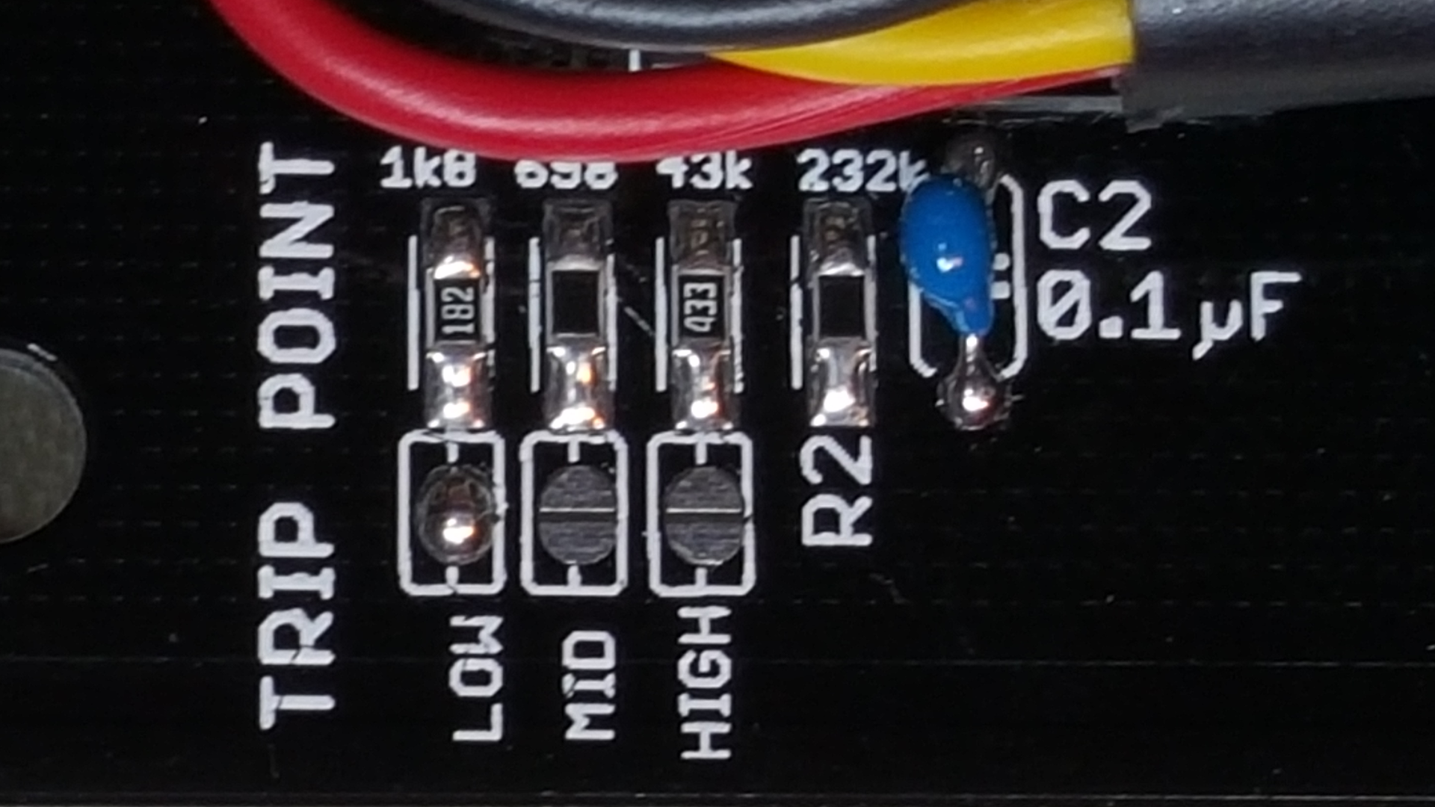

***Trip Point set to Low***

**Disconnecting 5VDC from a C64 Power Supply**

Unlike the 5VDC, the 9VAC of a C64 power supply rarely fails. The SaV64 allows you disconnect the 5VDC from the C64 power supply. This allows you to continue using the C64 power supply for 9VAC along with another 5VDC power source.

*IMPORTANT* Before you can use a separate 5VDC power supply in conjunction with the C64’s 9VAC, you must cut a trace on the SaV64 PCB. This trace can easily be reconnected by installing a jumper wire between the two terminals of the terminal block.

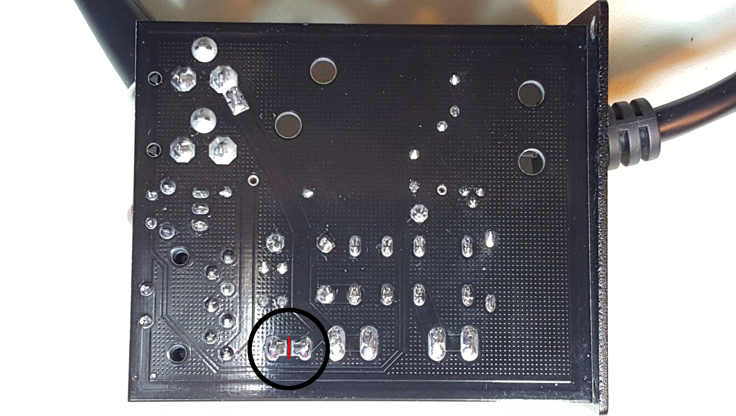

***Cut the trace marked in red.***

***Use a voltmeter between the two solder points to check that the trace is completely disconnected.***

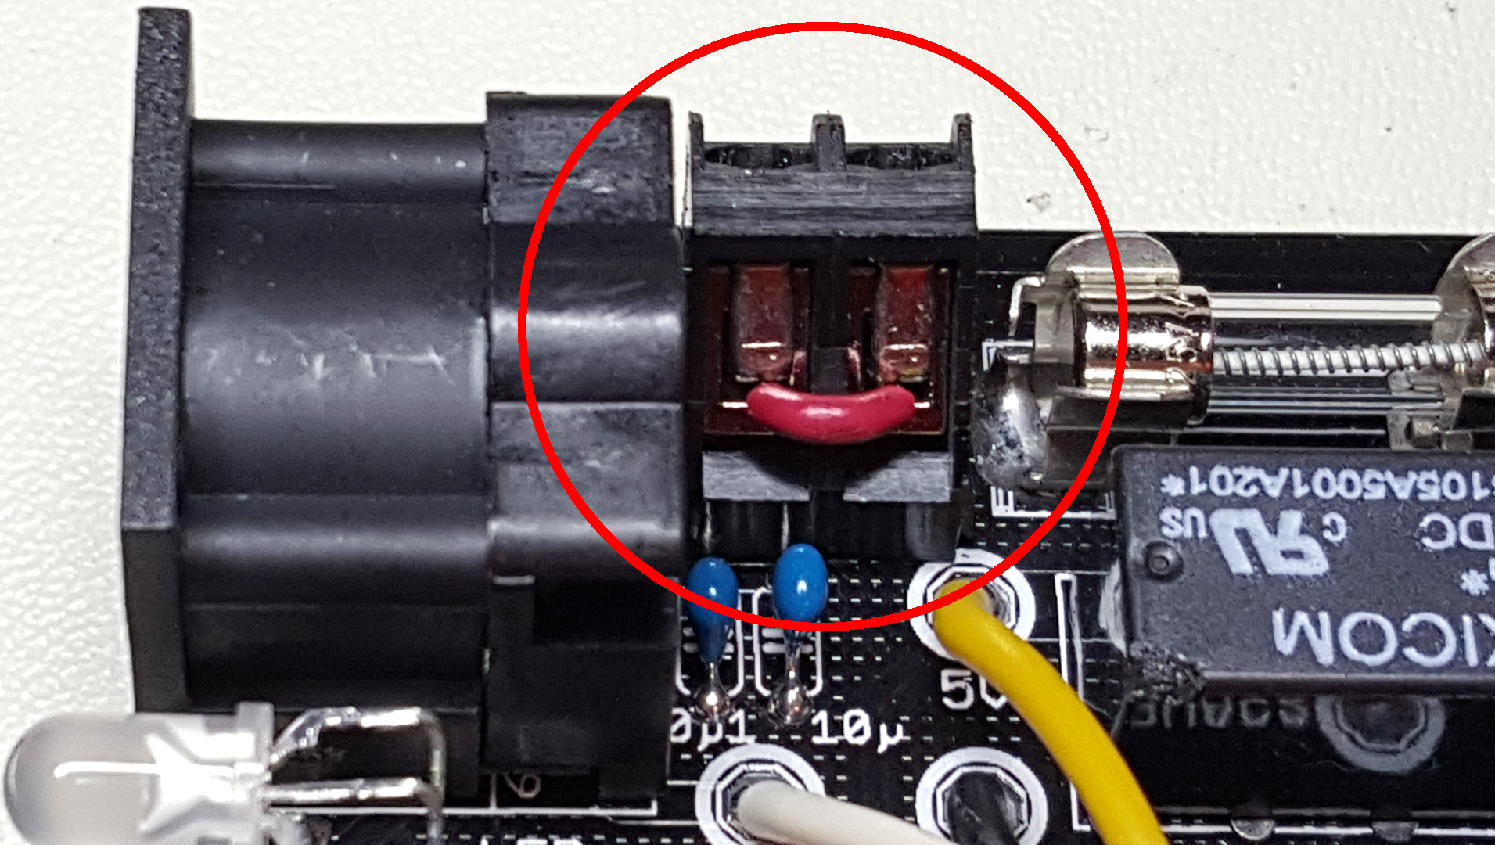

***Jumper Wire to Reconnect C64 PSU 5VDC***

**Disconnecting the 5VDC Barrel Connector**

The 5VDC Barrel connector is connected to the circuit by default. When using a C64 power supply, the voltage from the power supply is present at the barrel connector. The barrel connector can be disconnected from the SaV64 by removing the solder at the location shown below.

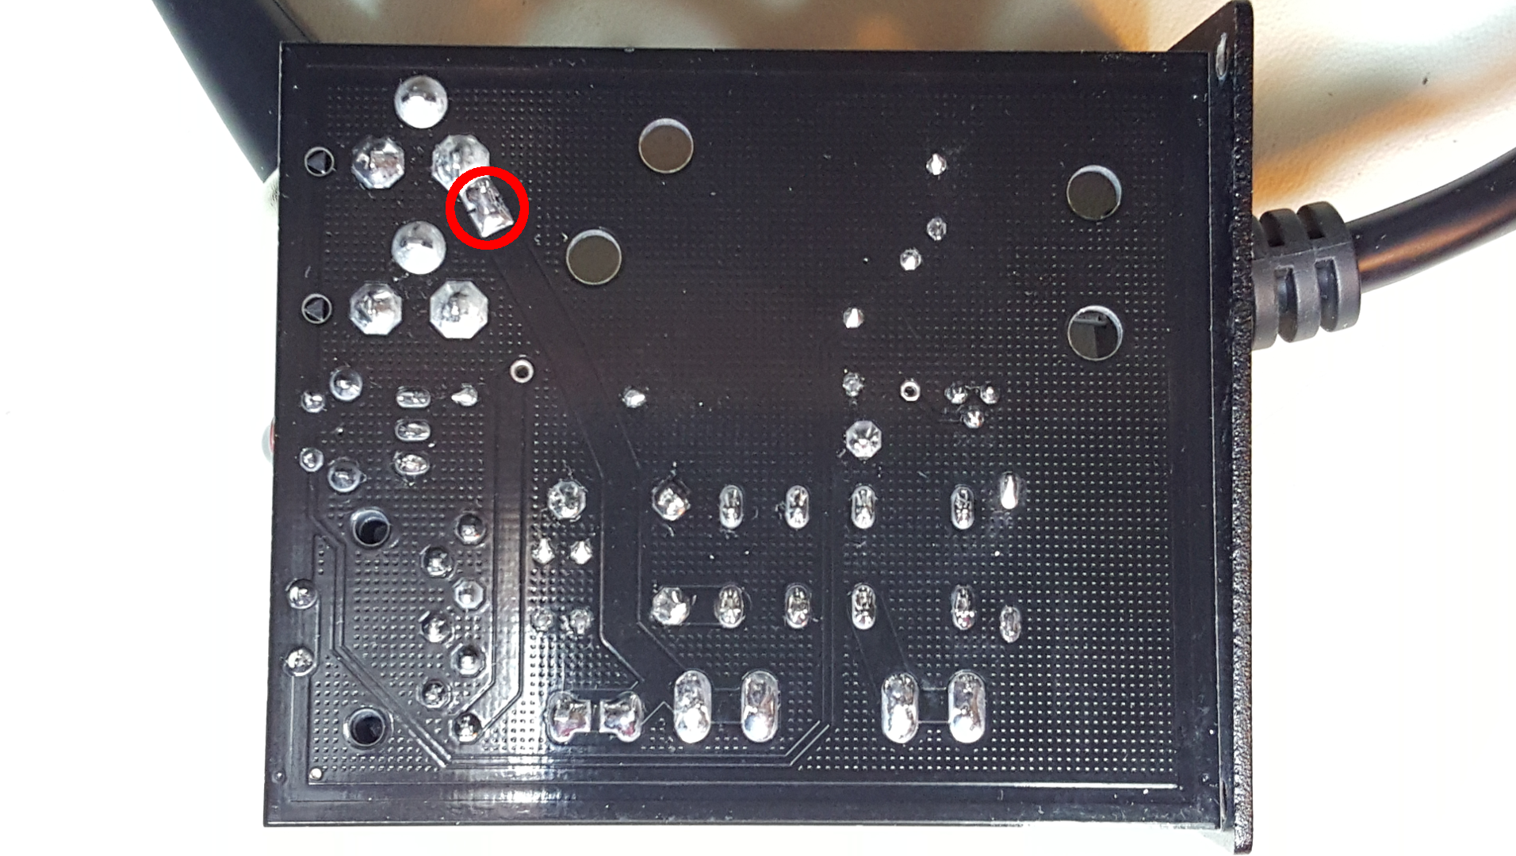

**Disconnecting the 9VAC Barrel Connector**

The 9VAC Barrel connector is connected to the circuit by default. When using a C64 power supply, the voltage from the power supply is present at the barrel connector. The barrel connector can be disconnected from the SaV64 by removing the solder at the location shown below.

